Our Mission
To foster a teaching congregation that is gathering, growing, and going!

Contact Information
If you would like:
- more information about Grace
- prayer for a concern you have
- a visit from someone from the church
Service Time
Sunday Mornings @ 9:00 A.M.
Telephone
(815) 827-3559
Postal address
506 Willow, P.O. Box 117, Maple Park, IL 60151
E-mail
General Information: pastor@gracemaplepark.org
Webmaster: creation_dayzn@yahoo.com
GROWING – AS DISCIPLES OF JESUS CHRIST
RETHINKING – THE WAY WE WORSHIP
ACTING – IN MISSION IN OUR COMMUNITY AND WORLD
CARING – FOR EACH OTHER AS GOD’S CHILDREN
EVANGELIZING – TO ALL WHO NEED GOD’S LOVE

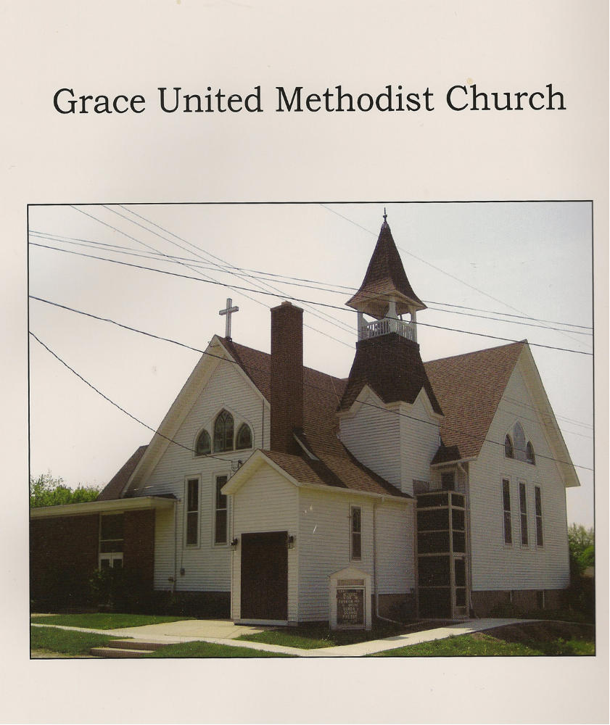
January 24, 2010

Grace UMC
Order of Worship
January 24, 2010

May all that we do bring glory and pleasure to God.

Preparation: Please be seated and bring your mind and body back to the Heart of Worship.

Welcome/Announcements (See Insert for announcements)

Meet and Greet:
Luke 10:27 “Love your neighbor as yourself.”
Please greet each other in the spirit of Jesus’ command.

Time with the Children

Giving our Hearts to God in Song:
“Open Up the Gates”
“Glory to You”
“Let the Praises Ring”

Message:
CHURCH’N IT UP – Purpose Driven Attendance

Offering:
“What Life Would Be Like”

Time of Prayer, Joys, Concerns and Thanksgiving

Closing Song:
“One Way”

May the Lord bless you and keep you until we can be together again in the name of Jesus – the Christ.

CHURCH’N IT UP
Purpose Driven Attendance

- To _____________ and recharge.
Romans 10:17

- To build significant _______________________________.
Genesis 2:18-20

- To be ___________________.
1 Peter 5:5. 1 Corinthians 15:23

- To ________ and _______________ others.
Matthew 25:41-45. Hebrews 10:25

- To unite in __________________, _____________ and _______________.
Matthew 18:19-20, Acts 4:31

- To ________ and ___________ in our walk with Jesus Christ.
Ephesians 4:14-16, John 15:4-5, Galatians 5:16-18

- To ________________________ the body.
1 Corinthians 12:12-27, Luke 15:4-7

